Credit Card Fraud Detection
Case Study Report — Sparkov Transaction Dataset
Algorithms: Linear Support Vector Machine (Linear SVM), Random Forest, and a Soft Voting Classifier (Random Forest + Logistic Regression)
Results below are taken from the executed Google Colab notebook (Credit_Card_Fraud_Detection_Sparkov_FAST). To keep run time short, models were trained and evaluated on stratified samples of the full files, so all metrics describe the sampled test set rather than the complete dataset.

1. Abstract
This case study compares three supervised learning approaches for detecting fraudulent credit-card transactions in the simulated Sparkov dataset: a Linear SVM, a Random Forest, and a soft-voting ensemble that combines a Random Forest with Logistic Regression. The models were trained on a stratified sample of 50,000 transactions from fraudTrain.csv and evaluated on a stratified sample of 15,000 transactions from fraudTest.csv, which contained 58 fraudulent transactions (0.387%). Random Forest delivered the best overall result, with F1-score 0.6667, precision 0.8049, ROC-AUC 0.9500, and average precision (AP) 0.6683. It detected 33 of 58 frauds with only 8 false alarms. The Linear SVM reached the highest recall (0.6552) but a precision of just 0.0279, producing 1,322 false alarms. The voting ensemble caught 36 frauds but raised 48 false alarms, so it did not improve on the Random Forest alone. The results show why precision, recall, and precision–recall evaluation are needed when the positive class is rare.

2. Problem statement and dataset
The objective is to classify each credit-card transaction as legitimate (is_fraud = 0) or fraudulent (is_fraud = 1). Fraud is rare, so a model can obtain very high accuracy by predicting that nearly every transaction is legitimate; fraud-focused metrics are therefore required. The data come from two files, fraudTrain.csv and fraudTest.csv, stored in Google Drive and loaded in the notebook.
Dataset characteristic | Full file | Sample used
Training transactions | 1,296,675 | 50,000 (3.86%)
Test transactions | 555,719 | 15,000 (2.70%)
Columns per file | 23 | 23 (13 used as model inputs)
Training fraud rate | Not computed | 0.578% (≈289 frauds)
Test fraud rate | Not computed | 0.387% (58 frauds)
Test legitimate transactions | Not computed | 14,942
Target | is_fraud | is_fraud

Both samples were drawn with stratification on the target so that the fraud proportion of each file was preserved. The training and test samples differ slightly in fraud rate (0.578% versus 0.387%), reflecting the two source files.

3. Experimental methodology
The notebook uses the two files as provided: the training sample (50,000 rows) is used to fit every model, and the test sample (15,000 rows) is used only for evaluation. Stratified sampling used random_state = 42. Unlike a tuned experiment, no separate validation split or hyperparameter search was run; each model was trained once with a fixed configuration.

Feature engineering
A compact feature set of 13 columns was used. Time-based features were derived from trans_date_trans_time (hour of day, day of week, and month), and customer age was computed from the date of birth at the time of the transaction (clipped to 0–120 years). The remaining numeric inputs were amt, lat, long, city_pop, merch_lat, and merch_long, giving 10 numeric features. Three categorical features were used: category, gender, and state. Identifier-type columns were not used.

Preprocessing
A ColumnTransformer inside each scikit-learn pipeline applies median imputation and standard scaling to numeric features, and most-frequent imputation followed by one-hot encoding (unknown categories ignored) to categorical features. Because preprocessing sits inside the pipelines, imputation values, scaling statistics, and encoder categories are learned from training data only, which avoids leakage into the test set.

Model configurations
Model | Configuration
Linear SVM | LinearSVC; class_weight = "balanced"; max_iter = 2000
Random Forest | 60 trees; max_depth = 18; min_samples_leaf = 2; class_weight = "balanced_subsample"; n_jobs = -1
Logistic Regression (ensemble member) | class_weight = "balanced"; solver = "liblinear"; max_iter = 300
Soft Voting Classifier | Random Forest + Logistic Regression; voting = "soft"; weights = [2, 1]

Evaluation metrics
Accuracy is the fraction of all transactions classified correctly; precision is the fraction of predicted frauds that are truly fraudulent; recall is the fraction of actual frauds that are detected; and F1-score is the harmonic mean of precision and recall. ROC-AUC measures how well the model ranks fraudulent transactions above legitimate ones across all thresholds, and Average Precision (AP) summarizes the precision–recall curve, which is more informative than ROC-AUC when the positive class is very rare. The Linear SVM was scored with its decision-function values, while the Random Forest and the voting ensemble were scored with predicted fraud probabilities.

4. Linear SVM
The Linear SVM separates the classes with a single linear boundary in the preprocessed feature space. Balanced class weights increase the penalty for misclassifying the rare fraud class. Training and prediction took 1.5 seconds, making it the fastest model tested.
Metric | Accuracy | Precision | Recall | F1-score
Test value | 0.9105 | 0.0279 | 0.6552 | 0.0536

ROC-AUC was 0.8140 and AP was 0.0987. The model identified 38 of the 58 fraudulent transactions (recall 0.6552) but also flagged 1,322 legitimate transactions as fraud, so only about 2.8% of its alerts were genuine fraud. This is roughly 35 false alarms for every fraud detected, which would overwhelm a manual review team.
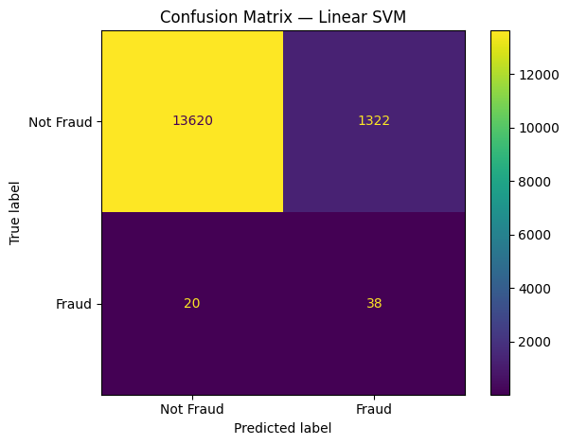
Figure 1. Confusion matrix for the Linear SVM on the 15,000-transaction test sample.

5. Random Forest
A Random Forest averages the votes of many decision trees built on bootstrap samples and random feature subsets, which allows it to capture non-linear interactions between amount, category, time, and location. The notebook used 60 trees with a maximum depth of 18, a minimum of two samples per leaf, and balanced_subsample class weights to counter the class imbalance. Training and prediction took 8.3 seconds.
Metric | Accuracy | Precision | Recall | F1-score
Test value | 0.9978 | 0.8049 | 0.5690 | 0.6667

ROC-AUC was 0.9500 and AP was 0.6683, the highest of the three models on both. The forest detected 33 of 58 frauds and raised only 8 false alarms, so about 80% of its alerts were genuine fraud. Its main weakness is recall: 25 fraudulent transactions (43.1%) were missed.
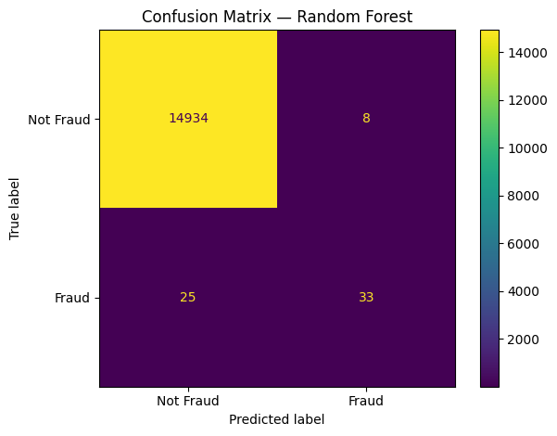
Figure 2. Confusion matrix for the Random Forest on the 15,000-transaction test sample.

6. Soft Voting Classifier (Random Forest + Logistic Regression)
The soft-voting ensemble averages the predicted fraud probabilities of a Random Forest and a Logistic Regression model, with the forest weighted twice as heavily as the logistic model. The aim was to combine the non-linear strength of the forest with the smoother probability estimates of a linear model. Training and prediction took 8.9 seconds.
Metric | Accuracy | Precision | Recall | F1-score
Test value | 0.9953 | 0.4286 | 0.6207 | 0.5070

ROC-AUC was 0.9353 and AP was 0.6005. Compared with the Random Forest alone, the ensemble detected three more frauds (36 versus 33) but generated 40 more false alarms (48 versus 8), lowering precision from 0.8049 to 0.4286. A likely explanation is that the class-balanced Logistic Regression assigns high fraud probabilities to many legitimate transactions, as the Linear SVM also did, which pulls the weighted average above the decision threshold more often.
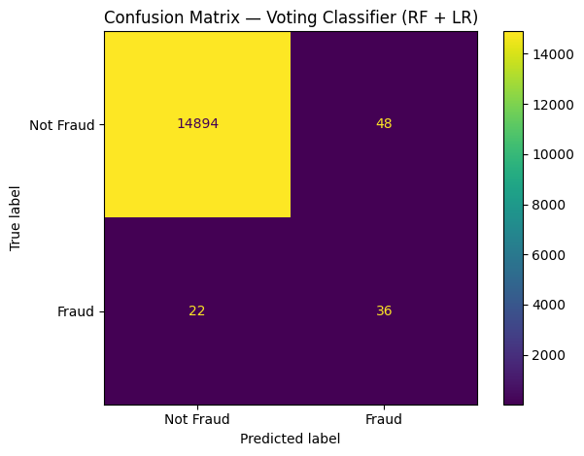
Figure 3. Confusion matrix for the soft voting ensemble on the 15,000-transaction test sample.

7. Final test-set comparison
All three models were evaluated on the same 15,000-transaction test sample. The best value in each column is shown in bold.
Model | Accuracy | Precision | Recall | F1-score | ROC-AUC | Avg. Precision
Linear SVM | 0.9105 | 0.0279 | 0.6552 | 0.0536 | 0.8140 | 0.0987
Random Forest | 0.9978 | 0.8049 | 0.5690 | 0.6667 | 0.9500 | 0.6683
Voting (RF + LR) | 0.9953 | 0.4286 | 0.6207 | 0.5070 | 0.9353 | 0.6005

Random Forest ranks first on accuracy, precision, F1-score, ROC-AUC, and AP; the Linear SVM ranks first only on recall, at the cost of very low precision. Accuracy alone is misleading here: because 14,942 of the 15,000 test transactions are legitimate, a model that never flagged fraud would score 0.9961. Both the Linear SVM (0.9105) and the voting ensemble (0.9953) score below that trivial baseline, and the Random Forest (0.9978) only just exceeds it, which is why the remaining metrics matter.
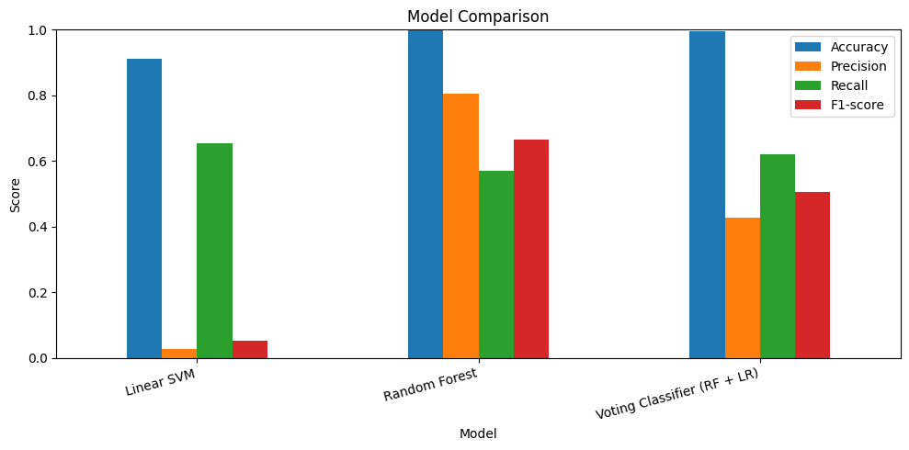
Figure 4. Accuracy, precision, recall, and F1-score for the three models on the test sample.
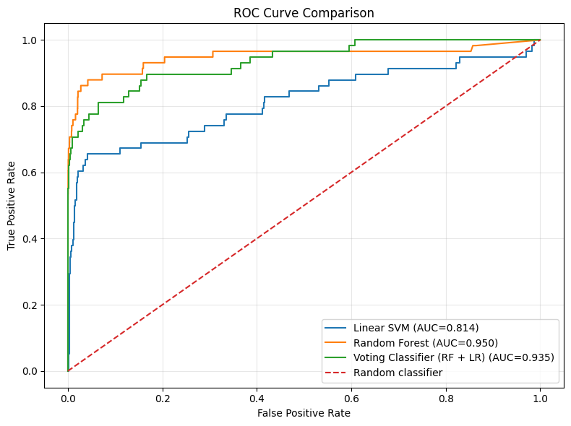
Figure 5. ROC curves for the three models (the dashed line is a random classifier).
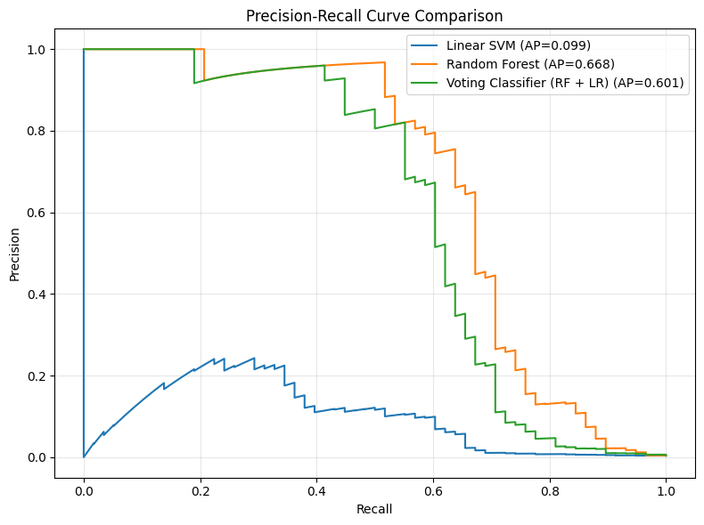
Figure 6. Precision–recall curves for the three models, with average precision (AP) in the legend.
The ROC curves show the Random Forest (AUC 0.950) ranking transactions better than the voting ensemble (0.935) and the Linear SVM (0.814). The precision–recall curves separate the models more sharply: the Linear SVM’s precision stays near the base rate, while the Random Forest holds high precision over a wider range of recall.

8. Confusion-matrix analysis
Model | True negatives | False positives | False negatives | True positives
Linear SVM | 13,620 | 1,322 | 20 | 38
Random Forest | 14,934 | 8 | 25 | 33
Voting (RF + LR) | 14,894 | 48 | 22 | 36

All models were evaluated on 14,942 legitimate and 58 fraudulent transactions (Figures 1–3 show the individual matrices). The Linear SVM missed the fewest frauds (20, or 34.5%) but triggered 1,322 false alarms. The Random Forest missed the most frauds (25, or 43.1%) but produced only 8 false alarms. The voting ensemble sits between them, missing 22 frauds (37.9%) with 48 false alarms. Expressed as false alarms per detected fraud, the cost is about 34.8 for the Linear SVM, 1.3 for the voting ensemble, and 0.24 for the Random Forest. Whether the Random Forest’s extra missed frauds are acceptable depends on the relative cost of a missed fraud versus a reviewed false alarm.

9. Discussion and limitations
The Random Forest outperformed the other models on five of six summary measures, supporting the value of non-linear models for this transaction data. The Linear SVM shows the typical failure of class-weighted linear models on rare events: it recovers many frauds but floods the review queue. The soft-voting ensemble did not beat its strongest component, which shows that combining models only helps when the added model contributes complementary, not merely noisier, information. Across all models, recall remained between 0.57 and 0.66, so a substantial share of fraud went undetected.
Limitations. (1) Both training and test data are stratified samples (about 3.9% and 2.7% of the full files); results on the complete data could differ. (2) The test sample contains only 58 frauds, so each detected or missed fraud shifts recall by about 1.7 percentage points, and the differences between models on recall are within this noise. (3) No hyperparameter search, validation split, or cross-validation was performed, and the Random Forest was limited to 60 trees for speed. (4) The default decision thresholds were used; tuning them for investigation costs could change the precision–recall trade-off. (5) The notebook suppresses warnings, so possible convergence warnings for the LinearSVC (max_iter = 2000) were not visible. (6) Sparkov is simulated data and may not reflect real fraud behavior. (7) Training time was measured per model including prediction and scoring, not deployment latency. (8) AP is not identical to the trapezoidal area under the PR curve.

10. Conclusion
Among the three models tested, the Random Forest achieved the strongest measured performance: F1-score 0.6667, precision 0.8049, ROC-AUC 0.9500, and AP 0.6683, with 33 frauds detected and 8 false alarms. The soft-voting ensemble (F1-score 0.5070) increased recall slightly but at a large precision cost, and the Linear SVM (F1-score 0.0536) was impractical because of its 1,322 false alarms. The study supports evaluating imbalanced fraud classifiers with precision, recall, F1-score, ROC-AUC, AP, and confusion matrices rather than accuracy alone. Recommended next steps are to train on the full dataset, tune hyperparameters and decision thresholds with cross-validation, and test cost-sensitive objectives.

11. Reproducibility and references
Implementation: Python in Google Colab with pandas, NumPy, matplotlib, and scikit-learn; random_state = 42; MAX_TRAIN_ROWS = 50,000 and MAX_TEST_ROWS = 15,000. Notebook: Credit_Card_Fraud_Detection_Sparkov_FAST.ipynb. The notebook saves the metric table (model_comparison_metrics_fast.csv) and per-model prediction files (actual label, predicted label, and fraud score) to the CreditCardFraudDetection folder in Google Drive.
Dataset: Sparkov Data Generation, simulated credit-card transactions (B. Harris), distributed on Kaggle as the Credit Card Transactions Fraud Detection Dataset (fraudTrain.csv and fraudTest.csv).
Software: Pedregosa, F. et al. (2011). Scikit-learn: Machine Learning in Python. Journal of Machine Learning Research, 12, 2825–2830.
Algorithm background: Breiman, L. (2001). Random forests. Machine Learning, 45, 5–32. Fan, R.-E., Chang, K.-W., Hsieh, C.-J., Wang, X.-R., & Lin, C.-J. (2008). LIBLINEAR: A library for large linear classification. Journal of Machine Learning Research, 9, 1871–1874.

Appendix: Implementation evidence
The following classification reports and run log are reproduced from the notebook output.

Appendix A1. Run log and combined metrics
Original train shape: (1296675, 23)
Original test shape: (555719, 23)
Sampled train shape: (50000, 23)
Sampled test shape: (15000, 23)
Training fraud rate: 0.00578
Testing fraud rate: 0.00387

Finished Linear SVM in 1.5 seconds.
Finished Random Forest in 8.3 seconds.
Finished Voting Classifier (RF + LR) in 8.9 seconds.

Accuracy Precision Recall F1-score ROC-AUC Avg Prec
Linear SVM 0.9105 0.0279 0.6552 0.0536 0.8140 0.0987
Random Forest 0.9978 0.8049 0.5690 0.6667 0.9500 0.6683
Voting Classifier (RF + LR) 0.9953 0.4286 0.6207 0.5070 0.9353 0.6005

Appendix A2. Linear SVM classification report
precision recall f1-score support

0 0.9985 0.9115 0.9530 14942
1 0.0279 0.6552 0.0536 58

accuracy 0.9105 15000
macro avg 0.5132 0.7833 0.5033 15000
weighted avg 0.9948 0.9105 0.9496 15000

TN=13,620 | FP=1,322 | FN=20 | TP=38

Appendix A3. Random Forest classification report
precision recall f1-score support

0 0.9983 0.9995 0.9989 14942
1 0.8049 0.5690 0.6667 58

accuracy 0.9978 15000
macro avg 0.9016 0.7842 0.8328 15000
weighted avg 0.9976 0.9978 0.9976 15000

TN=14,934 | FP=8 | FN=25 | TP=33

Appendix A4. Voting Classifier (RF + LR) classification report
precision recall f1-score support

0 0.9985 0.9968 0.9977 14942
1 0.4286 0.6207 0.5070 58

accuracy 0.9953 15000
macro avg 0.7135 0.8087 0.7523 15000
weighted avg 0.9963 0.9953 0.9958 15000

TN=14,894 | FP=48 | FN=22 | TP=36

